Socket A - AMD Processor

Heat sink

Installation Guide

Due to the high performance of AMD Athlon and Duron processors it is essential that this guide be read carefully and in its entirety to gain a thorough understanding of the heat sinking requirements of these CPU’s.

WARNING: All AMD processors are fully tested after manufacture. This means, that if a processor is predisposed to thermal failure through faulty manufacture then it would have failed during testing and you would not have possession of the processor now. Therefore, if thermal failure does occur when starting your computer for the first time, it will invariably be as a result of the following instructions not being carried out to the letter, and since this fault would be due to incorrect installation of the processor any warranty claims for thermal failure will be void.

If you are inexperienced or have any doubt whatsoever as to your ability to heat sink a processor reliably then you should have this task performed by a qualified computer technician.

CAUTION: Never start the processor unless the heat sink is properly and firmly attached.
IMMEDIATE THERMAL FAILURE WILL RESULT—THE PROCESSOR WILL BE
PERMANENTLY DAMAGED.

NOTE: This guide is only for the installation of Heat Sinks using Phase-change thermal contact pads. Removal of this pad from a heat sink and the use of an alternative Thermal Paste are done at your own risk and incorrect installation may void warranty.

In this guide, the AMD Athlon or AMD Duron processor is installed in Socket A of the motherboard before installing the motherboard and processor assembly into the system chassis. This is usually the easiest way to install the processor and heat sink. For best results, always install the processor and its heat sink before installing any memory modules.

Figure 1 shows the bottom of a heat sink with a step. The stepped portion fits over the top of the socket, where the legend “Socket 462” is moulded into the plastic. When the heat sink is correctly installed, the heat sink base will not touch any portion of the socket.
Caution: The processor will overheat and fail if the heat sink is not installed so that it sits parallel to the top of the processor, or if the heat sink touches any part of the socket itself.
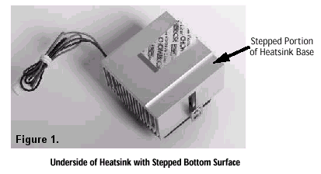
Figure 2 shows a Phase-change thermal contact pad covered by a protective plastic film.
Note: The phase-change thermal compound is very important to the efficiency and success of the heat sink. It (basically) melts and fills any microscopic voids in the surfaces of the processor and heat sink with a thermally conductive material.
Caution: If you have never installed a heat sink with this type of phase-change thermal material, we suggest that you not remove the protective plastic film until after you have practised installing the heat sink and mounting the clips on the socket. Notice also in Figure 2 that the film is removed by pulling rapidly at a right angle to the base. A quick lifting motion is the best way to remove this film.
Be aware that:
• Once the film is removed, immediately install the heat sink.
• The thermal compound must not come in contact with any foreign material.

Caution: Do not remove the heat sink from the processor, once it has been permanently installed. If you do remove the heat sink once the phase-change thermal compound has come in contact with the processor surface, the heat sink must be replaced, since the phase change material cannot be reused.
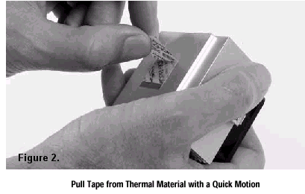
Figure 3 shows the WRONG way to install the heat sink. Do not tilt and push the heat sink onto the processor because doing so increases the chances of cracking the processor die. Instead, install the heat sink carefully with the bottom of the heat sink nearly parallel to the top surface of the processor. When properly installed, the heat sink will rest on the four rubber pads. The heat sink will come in contact with the processor die only when the retaining clip is fully installed.
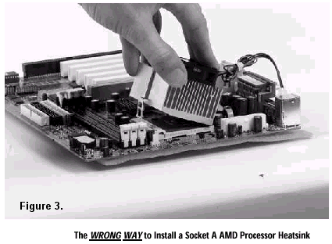
Caution: Never push down on the heat sink. This can cause irreparable damage to the processor die. All force should be applied only to the clip.

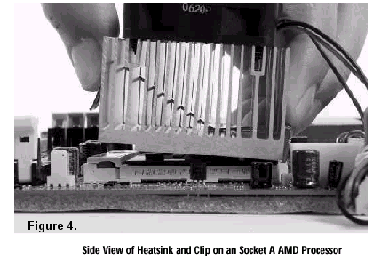
Figure 4 shows a side view of the heat sink with the retaining clip at the bottom of the heat sink. Make sure that the retaining clip is in this position before trying to install the heat sink. Notice that the clip is not symmetrical. The long end always attaches to the top of the socket (the end that reads “Socket 462”), while the short end engages the bottom of the socket. No matter which heat sink is used, the clip is always installed in the same manner. Also notice how the heat sink sits on the rubber pads. These pads are important to the proper installation of the heat sink, because they prevent the heat sink from rocking and cracking the processor die.

Figure 5 shows the first step in the installation of the heat sink. The heat sink must be placed on the processor with the short end of the clip attached to the centre lug at the bottom of the socket. It should fit onto this lug with finger pressure alone.
Note: The bottom of the heat sink is almost parallel with the top of the processor. This
is the only proper way to install the heat sink.
Caution: Never push down on the heat sink. Doing so can cause irreparable damage
to the processor die. All force should be applied to the clip only.
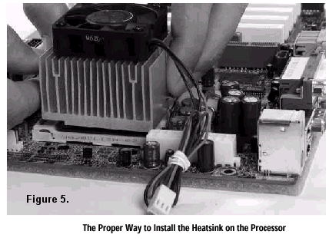
Figure 6 shows a side view of the heat sink with the clip installed on the centre socket lug at the bottom of the socket. Notice how the heat sink rests on the rubber pads and not on the processor itself. When the retention clip is fully installed, the rubber pads are compressed and the heat sink will then touch the surface of the processor die.
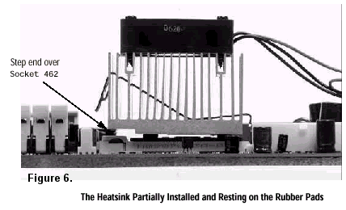
Note: Figure 6 illustrates the end of the clip, which goes over the top of the socket (the portion of the socket that reads “Socket 462”), is much longer than the other end. The clip is formed asymmetrically so that the pressure point is directly over the processor die. Although in the photo it seems like the clip is too far to one side, when the other side is installed, the clip contact point will be centred over the processor die.

Figure 7 shows the heat sink clip being installed on the centre lug at the top of the processor socket. To install this clip, push firmly only on the end of the clip. To install the clip, typically requires 5 to 10 kilograms of force.
Note: Using a screwdriver with a fairly large handle and small blade will distribute the load over a greater portion of the installer’s hands.
Figure 7 shows the heat sink clip being pushed down with a screwdriver inserted into the slot at the end of the clip. This is basically downward force on the clip. The clip must be pushed downward past the lug with a slight outward motion so that the clip goes over the lug on the socket.

Before starting the system, be sure to check the following:

 The surface of the heat sink is not contacting any portion of the socket.
 The protective liner for the thermal material has actually been removed.
 The long end of the clip is properly attached to the top of the socket.
 Verify that the heat sink retaining clip is completely seated on both centre socket lugs.
 The heat sink fan is plugged into the proper connector.

When the system is first powered-on, verify that the heat sink fan is turning at a relatively fast speed. It is very easy to have installed the screws too tightly, causing the fan housing to bind. If the fan is not turning properly, check to see that all the screws are tightened correctly.

This guide is an extract on cooling AMD Athlon / Duron processors courtesy of AMD.
For further information visit… www.amd.com.

