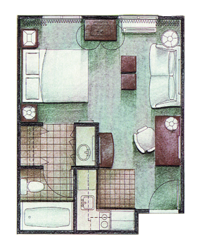
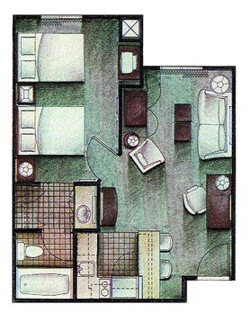
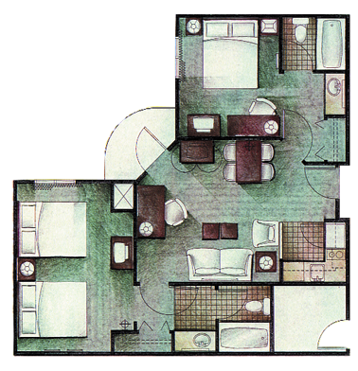
Studio (49)
(Queen Bed )
350 Square Feet

1-10 nights $ 79 per night
11-29 nights $ 69 per night
30+ nights $ 64 per night
One Bedroom (28)
(2 Doubles & Sleeper Sofa)
505 Square Feet

1-10 nights $ 79 per night
11-29 nights $ 69 per night
30+ nights $ 64 per night
Two Bedroom/Two Bath (11)
(1st Bedroom Queen, 2nd Bedroom 2 Dbls & Sleeper Sofa) 750 Square Feet

1-10 nights $ 109 per night
11-29 nights $ 99 per night
30+ nights $ 85 per night

1012 Airport Boulevard (919) 468-0180 Fax (919) 468-5605

Morrisville, NC 27560 e-mail: rduab@yahoo.com or staybridgerdu@yahoo.com
Minutes from RTP & Solution Center “ IBM’s Preferred Home Away Home”

2004 IBM Rates Include FREE High Speed Internet

Free Hot Continental Breakfast
Free Shuttle Service from RDU Airport & To IBM
Free Manager’s Reception Tues., Wed., Thurs.
24 Hour Convenience Store
Fitness Center/Free Guest Laundry
All Suites Have Kitchens!

