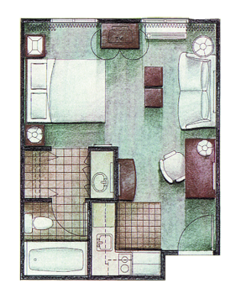
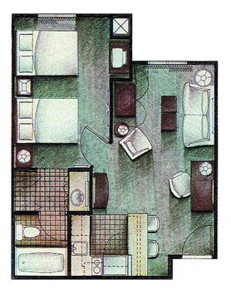
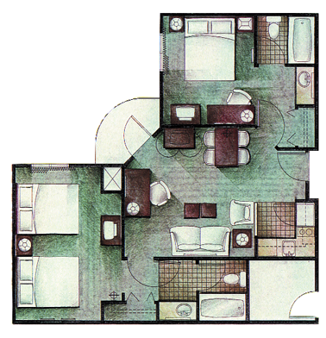
Studio (49)
(Queen Bed )
350 Square Feet

1-4 nights $ 69 per night
5-11 nights $ 69 per night
12-29 nights $ 69 per night
30+ nights $ 64 per night
One Bedroom (28)
(2 Doubles & Sleeper Sofa)
505 Square Feet

1-4 nights $ 69 per night
5-11 nights $ 69 per night
12-29 nights $ 69 per night
30+ nights $ 64 per night
Two Bedroom/Two Bath (11)
(1st Bedroom Queen, 2nd Bedroom 2 Dbls & Sleeper Sofa) 750 Square Feet

1-4 nights $ 99 per night
5-11 nights $ 99 per night
12-29 nights $ 99 per night
30+ nights $ 89 per night

1012 Airport Boulevard (919) 468-0180

Morrisville, NC 27560 (919) 468-5605 Fax
Minutes from RTP & Solution Center “ IBM’s Preferred Home Away Home”

2002 IBM Rates Include FREE High Speed Internet

Free Hot Continental Breakfast
Free Shuttle Service from RDU Airport & To IBM
Free Manager’s Reception Tues., Wed., Thurs.
24 Hour Convenience Store
Fitness Center/Free Guest Laundry
Brand New! All Suites Have Kitchens!

