Installation Guide for IBM Universal Management Agent (UMA)

Overview
This guide provides information for downloading the UMA program from the World Wide Web, installing it on your system, and configuring the browser.

Installing the Program

1. Download the UMA program installation file from the World Wide Web and place it in its own folder. The web site is http://www.pc.ibm.com/us/desktop/uma/.

2. Run the self-extracting executable file UMAW32.EXE to unpack the file. This creates the installation files, including the setup file SETUP.EXE, which you will use in a later step.

3. When prompted, enter the path of the folder where you want the installation files saved.

4. Close all open windows and programs.

5. From the desktop, click on Start.

6. Click on Run.

7. Type the path to the SETUP.EXE file; then, click on OK.

8. The Installation Wizard is displayed. Follow the instructions on the screen to select a directory where the UMA program will be installed.

9. You can choose among Typical, Custom, or Enterprise Console Integration installation for the UMA program, as shown in the following illustration:
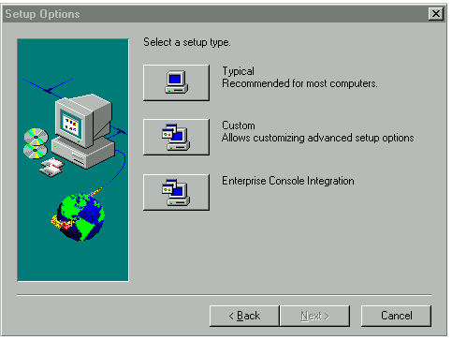

- For Typical Installation, proceed to step 10.
- For Custom Installation, proceed directly to step 11.
- For Enterprise Console Integration installation, proceed directly to step 12. Use Enterprise Console Integration only if you already have Tivoli Management Console installed on your network.

- In the Typical Setup:

- Choose whether you want to include LANDesk Client Manager in the installation. LANDesk Client Manager (LDCM) provides an alternative method of viewing a subset of UMA information outside the browser environment.

- When prompted, enter a User ID and Password to access the UMA program. This ID and password is for administration-level access. Please check with your system administrator before entering an ID and password. The password cannot exceed 32 characters.

- Choose whether you want to install SNMP. SNMP is a set of network communication specifications that cover the basics of network management. In most instances, you will choose Yes. If you choose not to install it, the computer can not forward alerts through SNMP to systems management applications such as Microsoft SMS.

- If you chose to install LANDesk Client Manager, setup will then select the same directory you downloaded UMAW32.EXE for installing LANDesk Client Manager. To select an alternative directory, click on the Browse button. Then, click on Next.

- UMA Setup is complete. Restart your computer to run UMA.

- In the Custom Setup:

- Select any or all three optional components to install, as shown in the following illustration:

- IBM System Management is the primary component for the UMA program. You must select this component for the UMA program to install on your system.

- Select IBM Netfinity if you already have IBM Netfinity Manager installed on your network. Contact your system administrator if you are not sure.

- Select Tivoli Management Agent if you have Tivoli Management Console installed on your network. Contact your system administrator if you are not sure.

- After you have selected the components , click on Next.

- Choose whether you want to include LANDesk Client Manager in the installation. LANDesk Client Manager (LDCM) provides an alternative method of viewing a subset of UMA information outside the browser environment.

- Choose whether you want to install SNMP. SNMP is a set of network communication specifications that cover the basics of network management. In most instances, you will choose Yes. If you choose not to install it, the computer can not forward alerts through SNMP to systems management applications such as Microsoft SMS.

- When prompted, enter a User ID and Password to access the UMA program through the World Wide Web. This ID and password is for administration-level access. Please check with your system administrator before entering an ID and password. The password cannot exceed 32 characters.

- If you chose to install LANDesk Client Manager, setup will then select the directory C:\PROGRAM FILES\IBM\UMA for installing LANDesk Client Manager. To select an alternative directory, click on the Browse button. Then, click on Next.

- At the Netfinity Install window:

- At the Netfinity Install box, the default directory of C:\WNETFIN has been selected to install Netfinity. To select an alternative directory, type in the path of the directory in this field; then, click on Next. Click on Help if you want more information.

- Choose from the following three options for operating Netfinity:

- Select Passive Client Operation if you are installing Netfinity on a LAN-attached system for simplified remote-system access and management by a Netfinity Manager. Passive Client Operation is designed specifically for the remote management and access of Passive Client Systems by a Netfinity Manager.

- Select Active Client Operation if you are installing Netfinity on a LAN-attached system for simplified remote-system access and management by a Netfinity Manager, and for improved local system management. Active Client Operation will install such features as System Information Tool, System Profile, and Alert Manager System Monitor.

- Select Stand-Alone Operation if you are installing Netfinity on a system that is not connected to a network, but want the local system management capabilities of Netfinity. This will allow a user access to the Netfinity services that are useful for local system management.

- Click on Next after you choose which client operation you want.

- At the Network Driver Configuration screen, fill in the appropriate fields, then click on Save. Click on Help if you have questions about the fields on this screen.

- Click on Yes to add a line to the AUTOEXEC.BAT file.

g. At the Tivoli Management Agent installation window:

- At the Endpoint Installation Options window, click Next if you want to install LCF Runtime, or Lightweight Client Framework. Lightweight Client Framework extends the full function of the TME platform to a large number of desktop managed nodes. Choose this option if you have Tivoli Management Console already installed on the network. Contact your system administrator if you are not sure. The default destination directory for LCF Runtime is C:\TIVOLI\LCF. To change it, click on Browse, then select the directory you want. Then, click on Next.

- At the Endpoint Installation window, click on Next.

- At the Advanced Configuration window, you may enter a gateway interface port and endpoint port. The default port settings for both are 9494. If you are not sure if you should type in a different port, contact your system administrator. When you are finished, click on Next.

- Setup is complete. Restart your computer to run the UMA program.

- In the Enterprise Console Integration Setup:

- Choose Enterprise Console Integration only if you have Tivoli Management Console or Microsoft SMS installed on your network. If you are not sure, contact your system administrator

- Choose up to three components to install, as shown in the following illustration:

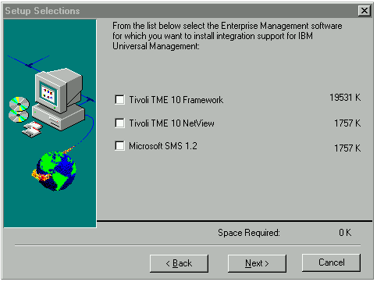

- Tivoli TME 10 Framework is the primary component for the Enterprise Console Integration setup.

- Select either Tivoli TME 10 NetView or Microsoft SMS 1.2 to enable distribution of client software on the network. If you are not sure which to select, contact your system administrator.

- Setup is complete. Restart your computer to run the UMA program.

Configuring Internet Explorer
Use the information in this section to verify that Internet Explorer is set up correctly for use with the UMA program

Note: The information in this section is subject to change, as new information becomes available. Updated information will be made available in the Troubleshooting Guide, which you can access through the UMA Web site at http://www.ibm.com/pc/desktop/uma.

Internet Explorer Security Settings
Use the following procedures to verify that that ActiveX, Java, and JavaScript are enabled
Internet Explorer 3.x
1. Open Internet Explorer 3.x.
2. Click on View, then Options, and then Security.
3. Verify that the following options are checked:

Option | Setting
Allow downloading of active content | √
Enable ActiveX controls and Plug-ins | √
Run ActiveX scripts | √
Enable Java programs | √

Because all of the ActiveX controls included with the UMA program are digitally signed by IBM, you can keep your safety level at your current setting. All safety levels, including high, are supported.

Internet Explorer 4.x
- Open Internet Explorer 4.x.
- Click on View, then Internet Options, and then Security.
- Verify that the security level is set at either Medium, Low, or Custom for the Internet and Internet zones that you will be using to access remote computers. If Custom is selected, click on Settings and verify that the following:

Option | Setting
Script ActiveX controls marked safe for scripting | Enable
Run ActiveX controls and plug-ins | Enable
Download signed ActiveX controls | Prompt
Java Permissions | High safety
Scripting of Java applets | Enable

To Uninstall UMA and its Components:

To uninstall UMA:

- Close all open windows and programs.

- From the desktop, click on Start.

- Click on Run.

- Type C:\WINDOWS\UNINUMA.EXE; then, click on OK. An MS-DOS screen will open and uninstall UMA and all of its components

To uninstall Tivoli Management Agent:

- Close all open windows and programs.

- From the desktop, click on Start.

- Select the Programs Folder.

- Select the Tivoli folder.

- Click on Uninstall LCF.

To uninstall Netfinity:

- Close all open windows and programs.

- From the desktop, click on Start.

- Select the Programs Folder.

- Select the Netfinity folder.

- Click on Netfinity Uninstall.

  © Copyright International Business Machines Corporation 1996. All rights reserved. Note to U.S. Government Users — Documentation related to restricted rights — Use, duplication or disclosure is subject to restrictions set forth in GSA ADP Schedule Contract with IBM Corp.

